# AVCDL Documentation Management

# Revision

Version 3

4/22/24 9:14 AM

# Author

Charles Wilson

# Abstract

This document describes the organization and management of documentation within the **AVCDL**.

# Audience

The audience of this document are those who will be contributing to the **AVCDL** repository or working with forks of the repository.

**Note:** This document is not subject to certification body review.

# License

This work was created by **Motional** and is licensed under the **Creative Commons Attribution-Share Alike (CC BY-SA-4.0)** License.

[**https://creativecommons.org/licenses/by/4.0/legalcode**](https://creativecommons.org/licenses/by/4.0/legalcode)

# Overview

The **AVCDL [1]** is presently made up of more than 780 files totaling over 280MB in size. The majority of these files are the sources used to create the primary document, 49 secondary documents, 9 certification documents, and 10 elaboration documents. Additionally, there are multiple templates and working materials used across the **AVCDL** document set.

This document will explore the organization of the **AVCDL** repository, the applications used to manipulate the source material, and the means by which the distribution materials are created.

# Organization

The document is divided into the following sections:

* Repository layout
* File formats used
* Authoring software
* Authoring workflow

# Repository Layout

The following shows the structure and general content of the **AVCDL** repository.

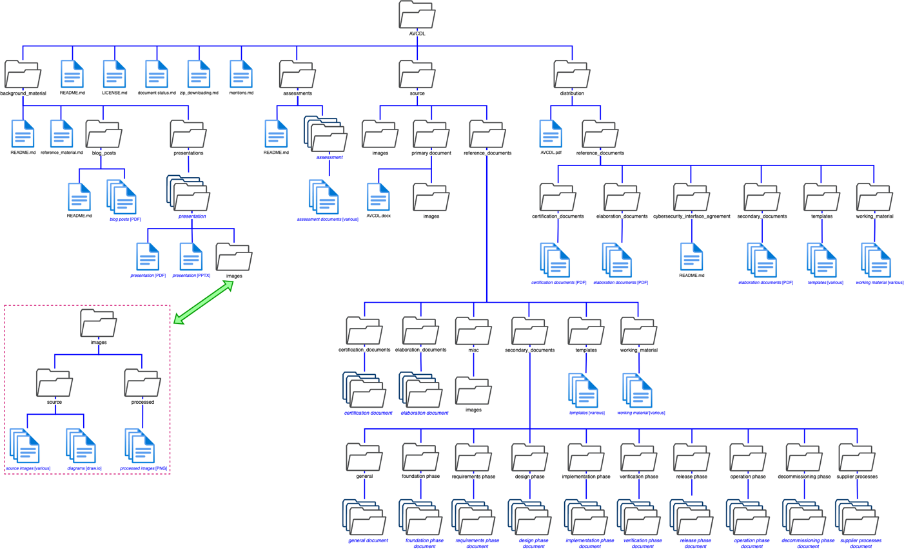

**Note:** The **images** folders have a structure shown in the bottom left of the diagram.

There are five main sections:

* Repository root
* Background material
* Assessments
* Source
* Distribution

We’ll examine each of these in turn.

## Repository Root

The following diagram shows the structure of the repository root.

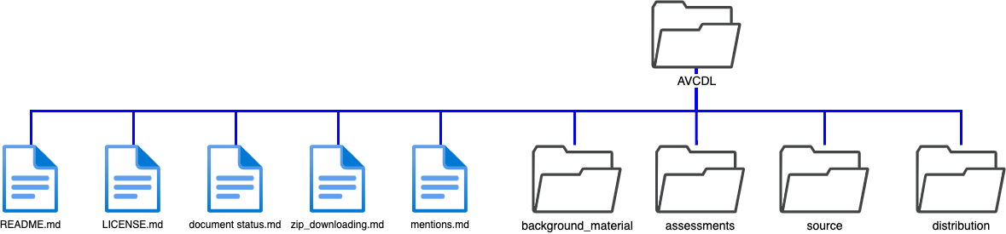

The focus here will be the individual files as the sub-folders will be addressed individually.

|  |  |
| --- | --- |
| **File** | **Description** |
| **README.md** | Site landing page |
| **LICENSE.md** | Site license information page |
| **document status.md** | Secondary document status tracker |
| **zip_downloading.md** | Non-git user repository downloading instructions |
| **mentions.md** | Internet AVCDL references |

**TODO:** There are some additional standard files that should be added. These include: **CONTRIBUTING.md** and **TODO.md [2]**.

### README.md

As the site landing page, it is expected that users read this page. It contains pointers to common areas of the repository.

### LICENSE.md

This file describes the license applied generally to the repository.

### document status.md

This file is used to track the progress of the secondary documents. A secondary document is considered complete once it has passed review by the certification body. This review is within the context of **ISO 21434**.

**Note:** Once the AVCDL review by the certification body is complete, this document will be reviewed and may be rewritten or removed.

### zip_downloading.md

This file provides instructions for non-git users to download the repository without having to use git client software.

### mentions.md

This file lists the AVCDL references from various external sources. It is a table with entries listed in reverse chronological order.

## Background Material

The following diagram shows the structure of the background material sub-tree.

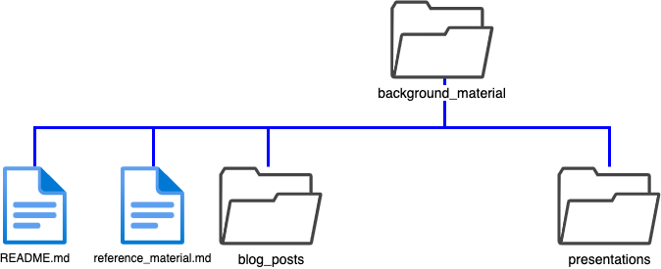

The focus here will be the individual files as the three folders will be addressed individually.

|  |  |
| --- | --- |
| **File** | **Description** |
| **README.md** | Background material navigation |
| **reference_material.md** | External **AVCDL** reference material |

### README.md

As the sub-tree landing page. It contains pointers the sub-sections.

### reference_material.md

This file contains a list of general level cybersecurity best practices and file format documents.

There are two sub-sections:

* Blog posts
* Presentations

### Blog Posts

The following diagram shows the structure of the blog posts sub-tree.

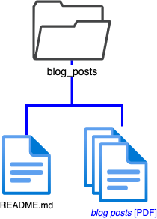

|  |  |
| --- | --- |
| **File** | **Description** |
| **README.md** | Blog post index |
| ***<blog post>.*PDF** | Individual blog posts |

### README.md

This landing page is used to provide a list of the blog posts with short descriptive text.

### *<blog post>*.PDF

The blog posts are encoded as PDFs as they come from external sources.

### Presentations

The following diagram shows the structure of the presentations sub-tree.

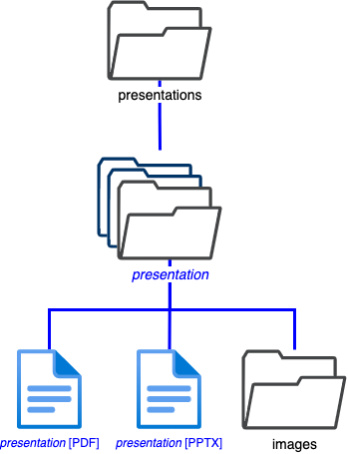

Each presentation will be in its own sub-folder.

|  |  |
| --- | --- |
| **File** | **Description** |
| ***<presentation>*.pdf** | PDF render of the presentation |
| ***<presentation>*.pptx** | Presentation source |

### *<presentation>*.pdf

Presentations are rendered as PDFs.

### *<presentation>*.pptx

The presentation source file is stored in Microsoft PowerPoint format.

#### Images

The following diagram shows the structure of the images sub-tree.

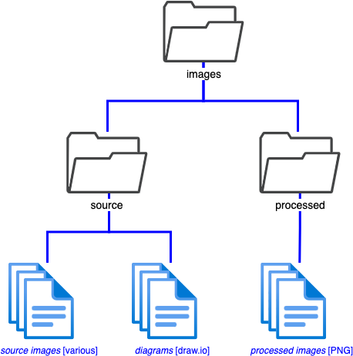

**Note:** The pattern used by the images folder is replicated throughout the repository.

The source folder contains the following files.

|  |  |
| --- | --- |
| **File** | **Description** |
| ***<source image>*** | Variously encoded source images |
| ***<diagram>*.drawio** | draw.io encoded diagrams |

### *<source image>*

Presentations are rendered as PDFs.

### *<diagram>*.drawio

Diagram source files are stored in draw.io format.

The processed folder contains the following files.

|  |  |
| --- | --- |
| **File** | **Description** |
| ***<processed image>*.png** | PNG encoded images |

### *<processed image>*.png

Processed images are rendered as PNGs.

## Assessments

The following diagram shows the structure of the assessments sub-tree.

The focus here will be the individual files as the three folders will be addressed individually.

|  |  |
| --- | --- |
| **File** | **Description** |
| **README.md** | Assessment index |

### README.md

This landing page is used to provide a list of the assessments with short descriptive text.

Each assessment will be contained within its own folder.

|  |  |
| --- | --- |
| **File** | **Description** |
| ***<assessment document>*** | Assessment document set |

### <assessment document>

This file set contains assessment report and associated informational files.

## Source

The following diagram shows the structure of the source sub-tree.

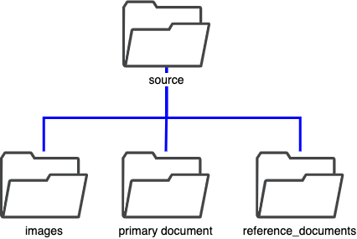

There are three sub-sections:

* Images (structured as previously discussed)
* primary document
* reference documents

### Primary Document

The following diagram shows the structure of the primary document sub-tree.

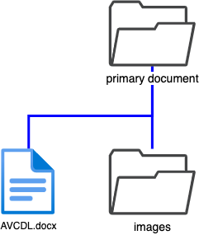

**Note:** The structure the primary document folder will be used for all individual documents.

|  |  |
| --- | --- |
| **File** | **Description** |
| **AVCDL.docx** | AVCDL primary document source |

### AVCDL.docx

The AVCDL’s primary source file is stored in Microsoft Word format.

**Note:** The structure the images folder has been detailed earlier.

### Reference Documents

The following diagram shows the structure of the reference_documents sub-tree.

**Note:** The structure of the primary document folder is used for all individual documents.

This folder contains the following types of material:

* Supporting documents (elaboration, and certification)
* Auxiliary material (templates and working material)
* Repository-specific material (misc)
* Secondary documents (directly supporting the **AVCDL** primary document)

#### Supporting Documents

|  |  |
| --- | --- |
| **Folder** | **Description** |
| **elaboration** | **AVCDL** elaboration topic document sources |
| **certification** | **AVCDL** standard / regulation certification document sources |

#### Auxiliary Material

|  |  |
| --- | --- |
| **Folder** | **Description** |
| **templates** | Documents used in conjunction with **AVCDL** secondary documents |
| **working_material** | Documents used in the construction of the **AVCDL** (cross-references) |

#### Repository-specific Material

|  |  |
| --- | --- |
| **Folder** | **Description** |
| **images** | Images used in the repository navigation pages |

#### Secondary Documents

The following diagram shows the structure of the secondary_documents sub-tree.

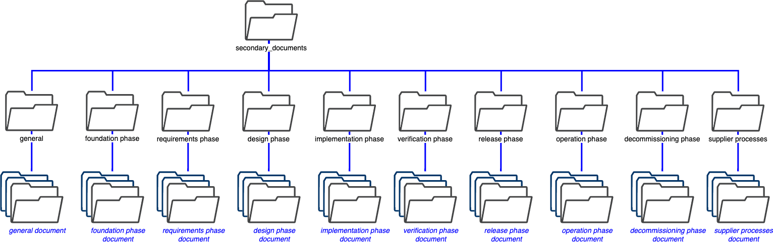

**Note:** The structure of the primary document folder is used for all individual documents.

This folder contains the following types of material:

##### Phase Requirement Documents

|  |  |
| --- | --- |
| **Folder** | **Description** |
| **foundation phase** | **AVCDL** foundation phase document sources |
| **requirements phase** | **AVCDL** requirements phase document sources |
| **design phase** | **AVCDL** design phase document sources |
| **implementation phase** | **AVCDL** implementation phase document sources |
| **verification phase** | **AVCDL** verification phase document sources |
| **release phase** | **AVCDL** release phase document sources |
| **operation phase** | **AVCDL** operation phase document sources |
| **decommissioning phase** | **AVCDL** decommissioning phase document sources |

##### Other Secondary Documents

|  |  |
| --- | --- |
| **Folder** | **Description** |
| **general** | General topic documents supporting the **AVCDL** |
| **supplier processes** | Documents supporting **AVCDL**-related supply chain activities |

## Distribution

The following diagram shows the structure of the distribution sub-tree.

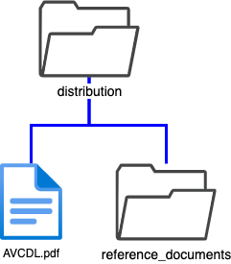

There are two elements:

|  |  |
| --- | --- |
| **File** | **Description** |
| **AVCDL.pdf** | AVCDL primary document [PDF] |

* reference documents

### Reference Documents

The following diagram shows the structure of the reference_documents sub-tree.

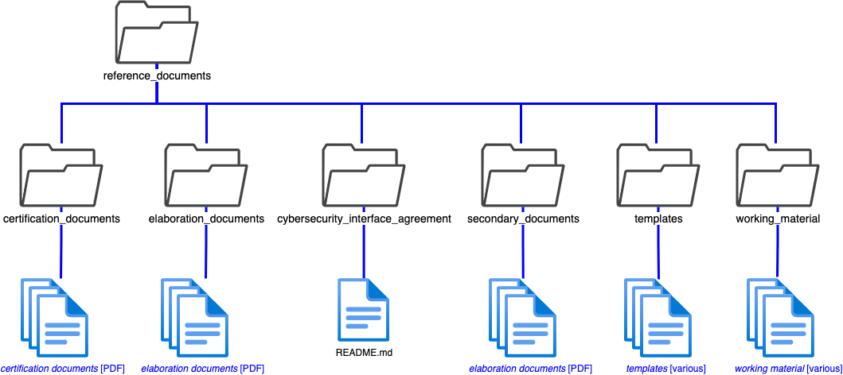

This folder mirrors the organization of the one in the source sub-tree.

This folder contains three types of material:

* Supporting documents (secondary, elaboration, and certification)
* Auxiliary material (templates and working material)
* Legacy material (cybersecurity interface agreement)

#### Supporting Documents

|  |  |
| --- | --- |
| **Folder** | **Description** |
| **secondary** | AVCDL phase requirement documents [PDF] |
| **elaboration** | AVCDL elaboration topic documents [PDF] |
| **certification** | AVCDL standard / regulation certification documents [PDF] |

#### Auxiliary Material

|  |  |
| --- | --- |
| **Folder** | **Description** |
| **templates** | Documents used in conjunction with AVCDL secondary documents |
| **working_material** | Documents used in the construction of the AVCDL (cross-references) |

**Note:** These files are copied as-is from the source sub-tree.

#### Legacy Material

|  |  |
| --- | --- |
| **Folder** | **Description** |
| **cybersecurity_interface_agreement** | Contains a readme pointing to moved materials |

# File Formats Used

This section covers the file formats used within the **AVCDL** documentation set.

|  |  |  |
| --- | --- | --- |
| **Format** | **Extension** | **Use** |
| **markdown [9]** | **.md** | Repository navigation pages |
| **PDF [10]** | **.pdf** | Distribution documents |
| **draw.io [15]** | **.drawio** | Diagram source |
| **MS Word [14]** | **.docx** | Document source |
| **MS PowerPoint [13]** | **.pptx** | Presentation source / complex diagrams |
| **MS Excel [12]** | **.xlsx** | Spreadsheets |
| **PNG [11]** | **.png** | Images |

## Rationale

The choice of these file formats was made based on practical considerations.

Early on, there was a desire to maintain the primary document in markdown format. The “apparent” web-like behavior this exposed led to an increasing desire for internal hyperlinking. This rapidly proved unmanageable as the document’s size and scope increased. Additionally, markdown is not sufficiently expressive to be used to convey the type of information contained within the **AVCDL**. Additionally, as the audience of the AVCDL includes certification bodies and a host of other non-software developers, markdown was impractical from a review standpoint.

The Microsoft suite formats (Word, Excel, PowerPoint) were selected to replace markdown. These are either natively supported or readily imported on all platforms of interest. Google docs formats were not used as they are not sufficiently expressive to represent the information contained within the **AVCDL**.

Diagrams are stored in draw.io format. As with the Microsoft suite, this is available on all platforms of interest.

Imagery is stored in PNG format. PNG is a lossless format not subject to generational degradation. Non-PNG imagery is rendered into PNG format before inclusion in the AVCDL documents.

Distribution documents use PDF in order to minimize the variation in final document representation.

**Note:** In the future, it may be desirable to move the document source to a format better suited to greater hyperlinking.

# Authoring Software

This section covers the software use in the creation of the **AVCDL** documentation.

|  |  |
| --- | --- |
| **Software** | **Use** |
| **MS VSCode [3]** | Markdown document editing |
| **PDF Expert [4]** | PDF editing |
| **drawio [5]** | Diagram editing |
| **MS Word [6]** | Document source editing |
| **MS PowerPoint [7]** | Presentation source editing |
| **MS Excel [8]** | Spreadsheet editing |
| **Preview (MacOS) [16]** | Image transcoding |

## Rationale

The choice of the above authoring software was made based on practical considerations.

Aside from PDF Expert, the software used to edit the **AVCDL** materials is either directly available on all platforms of interest, or in the case of the Microsoft Office suite, importable into readily available alternatives. As a MacOS based system was used in the creation of the **AVCDL** documents, the commercial PDF Expert editor, was used. Any PDF editor capable of handling image replacement would be acceptable.

A PDF editor was necessitated by the failure of Microsoft Word to properly embed PNG encoded images at their native resolution. Word down samples included images. I’m not sure whether this is occurring upon inclusion or during PDF generation. Regardless, it is necessary to use a PDF editor to replace the down sampled images in the distribution documents. Additionally, all hyperlinks to secondary documents must be made relative to the primary document. Microsoft Word sometimes creates fully qualified paths.

**Note:** In the future, it may be desirable to move to software better suited to handling greater hyperlinking and the complexity of management that such features entail.

# Authoring Workflow

This section covers the various activities used to transform the **AVCDL** source material into their distribution form. To simplify this document’s complexity a bit, we’ll consider the most complex case.

## Unified Workflow

The following shows the activities undertaken in order to create an **AVCDL** document from various source elements.

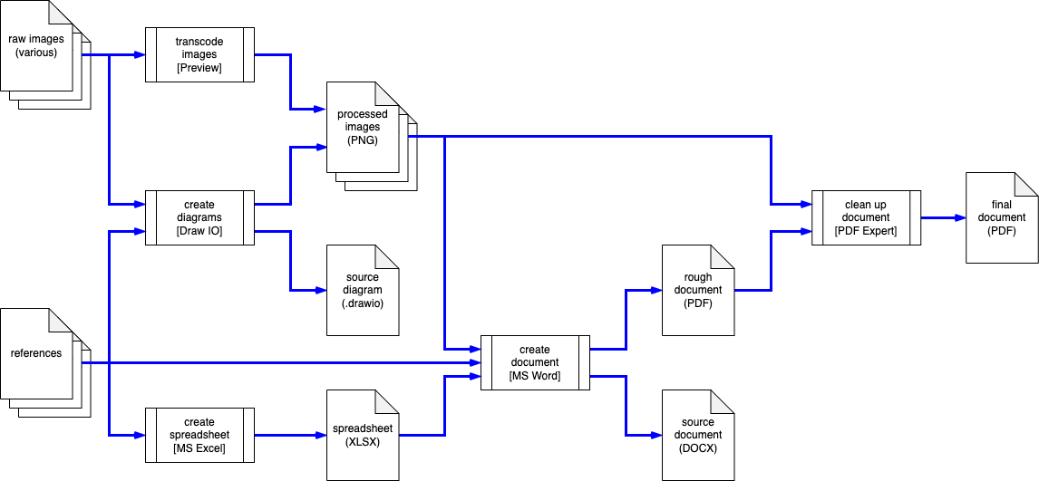

**Note:** File formats are shown in parentheses. Applications are shown in brackets.

## Workflow Diagram

The following shows the workflow using the AVCDL workflow notation:

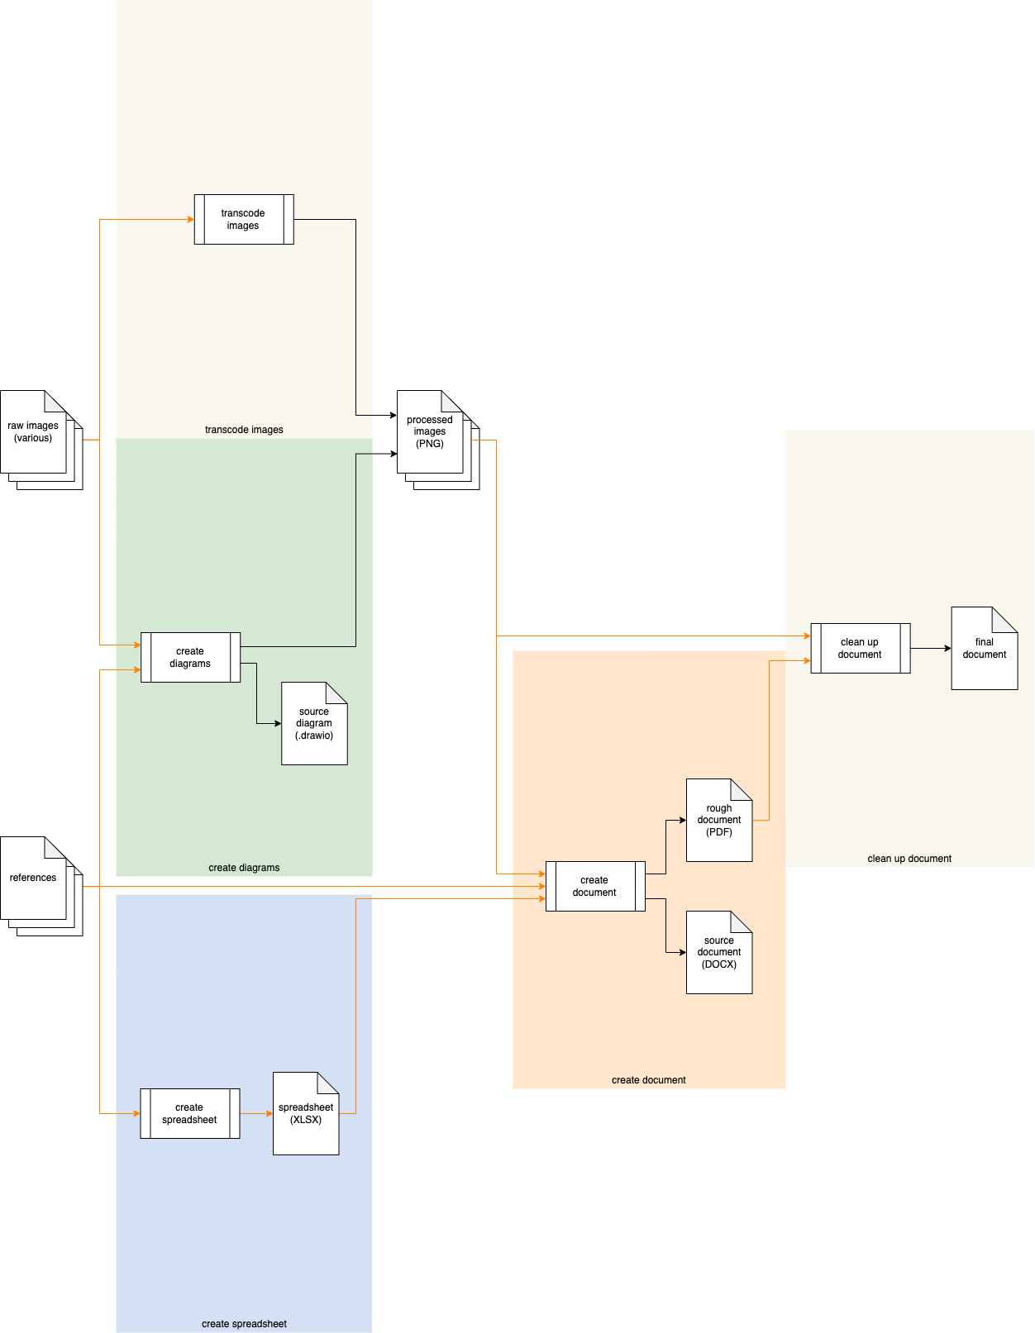

# Process

## Transcode Images

|  |  |
| --- | --- |
| **Inputs** | Raw images |
| **Outputs** | Processed images |
| **Application** | Preview (MacOS) |

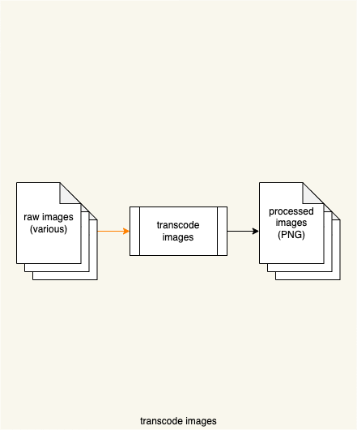

**Raw images** in various formats are transcoded using the MacOS **Preview** application to generate **processed images** in PNG format.

## Create Diagrams

|  |  |
| --- | --- |
| **Inputs** | Raw images  References |
| **Outputs** | Source diagram  Processed images |
| **Application** | Draw IO |

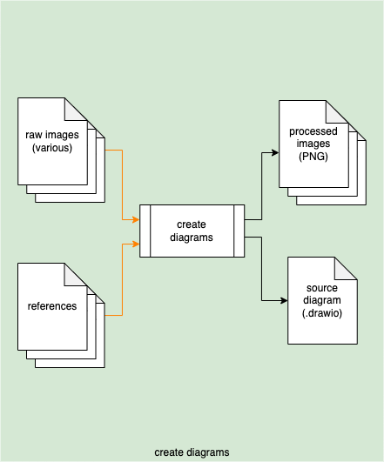

**Raw images** and other **references** are used as information sources to generate a **source diagram** using Draw IO. From the source diagram a set of **processed images** is exported.

**Note:** Exported images should be saved with transparency enabled.

## Create Spreadsheet

|  |  |
| --- | --- |
| **Inputs** | References |
| **Outputs** | Spreadsheet |
| **Application** | MS Excel |

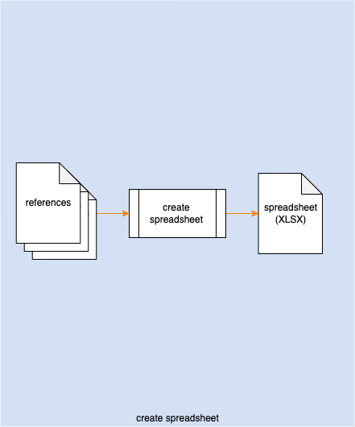

Various **references** are used as a basis for the creation of a **spreadsheet** using MS Excel.

## Create Document

|  |  |
| --- | --- |
| **Inputs** | Processed images  References  spreadsheet |
| **Outputs** | Source document  Rough document |
| **Application** | MS Word |

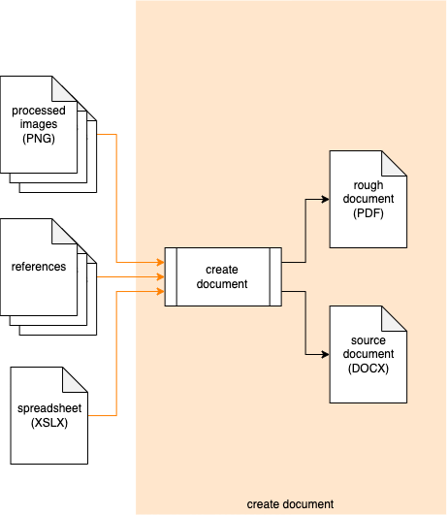

The **processed images**, **references** and **spreadsheet** are used as the basis of, or directly integrated into the **source document** using MS Word. This **source document** is exported as a **rough document**.

## Cleanup Document

|  |  |
| --- | --- |
| **Inputs** | Processed images  Rough document |
| **Outputs** | Final document |
| **Application** | PDF Expert |

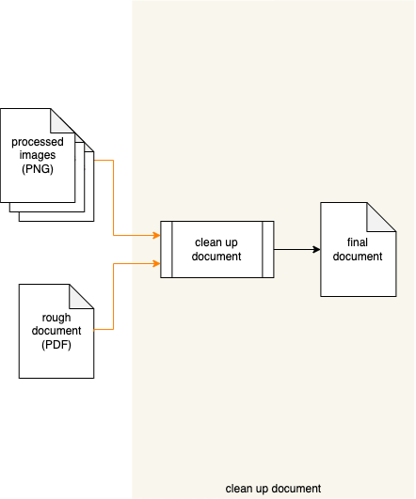

The **rough document** is modified using PDF Expert yielding a **final document**. Presently, there are two types of modification:

1. Improperly encoded images are replaced with their originals from the processed images set.
2. Non-relative hyperlinks are corrected to be relative.

**Note:** As mentioned earlier in this document, this step is necessitated by deficiencies in MS Word.

# Source to Distribution Workflow

The following diagram shows the source material to distribution material flow.

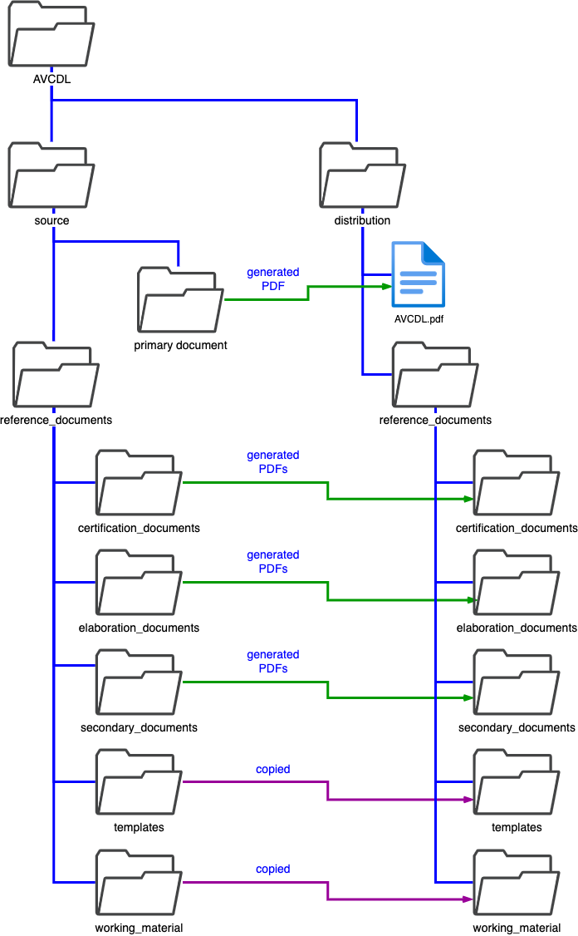

There are three cases:

## Generated Primary Document

The primary document’s [PDF] is generated into the top level of the distribution folder.

## Generated Reference Documents

The reference documents in the certification_documents and elaboration_documents folders are generated [PDF] into the corresponding folders in the distribution folder. The reference documents in the secondary_documents folders are generated [PDF] and aggregated into the secondary_documents folder in the distribution folder.

## Copied Reference Documents

The reference documents in the templates and working_material folders are copied into the corresponding folders in the distribution folder.

**Note:** This duplication of the templates and working material documents is done for consistency of the source and distribution trees.

# Local Working Copy

It is highly recommended that the local working copy of the **AVCDL** be separate from the git clone of the **AVCDL** repository. There are a few reasons for this.

1. Given that the **AVCDL** repository is public, extra steps to ensure that organizational materials don’t accidentally get pushed are warranted.
2. It is important to not push draft or exploratory materials
3. It is necessary when reorganizing the materials.
4. It allows for work on multiple new documents.

**Note:** It is recognized that keeping a separate working copy may lead to file not being pushed to the repository. The **AVCDL** repository has been maintained in this manner for over two years, and no major issues have been arisen.

# References

1. **AVCDL** (primary document)
2. **Common *special files* found in the root directory of a repository**[**https://github.com/kmindi/special-files-in-repository-root/blob/master/README.md**](https://github.com/kmindi/special-files-in-repository-root/blob/master/README.md)
3. **Visual Studio Code**[**https://code.visualstudio.com**](https://code.visualstudio.com)
4. **PDF Expert**  
   [**https://pdfexpert.com**](https://pdfexpert.com)
5. **draw.io**  
   [**https://www.diagrams.net**](https://www.diagrams.net)
6. **Microsoft Word**  
   [**https://www.microsoft.com/en-us/microsoft-365/word**](https://www.microsoft.com/en-us/microsoft-365/word)
7. **Microsoft PowerPoint**  
   [**https://www.microsoft.com/en-us/microsoft-365/powerpoint**](https://www.microsoft.com/en-us/microsoft-365/powerpoint)
8. **Microsoft Excel**  
   [**https://www.microsoft.com/en-us/microsoft-365/excel**](https://www.microsoft.com/en-us/microsoft-365/excel)
9. **Markdown**  
   [**https://en.wikipedia.org/wiki/Markdown**](https://en.wikipedia.org/wiki/Markdown)
10. **PDF**  
    [**https://en.wikipedia.org/wiki/PDF**](https://en.wikipedia.org/wiki/PDF)
11. **Portable Network Graphics**  
    [**https://en.wikipedia.org/wiki/Portable_Network_Graphics**](https://en.wikipedia.org/wiki/Portable_Network_Graphics)
12. **[MS-XLSX]: Excel (.xlsx) Extensions to the Office Open XML SpreadsheetML File Format**  
    [**https://docs.microsoft.com/en-us/openspecs/office_standards/ms-xlsx/2c5dee00-eff2-4b22-92b6-0738acd4475e**](https://docs.microsoft.com/en-us/openspecs/office_standards/ms-xlsx/2c5dee00-eff2-4b22-92b6-0738acd4475e)
13. **[MS-PPTX]: PowerPoint (.pptx) Extensions to the Office Open XML File Format**[**https://docs.microsoft.com/en-us/openspecs/office_standards/ms-pptx/efd8bb2d-d888-4e2e-af25-cad476730c9f**](https://docs.microsoft.com/en-us/openspecs/office_standards/ms-pptx/efd8bb2d-d888-4e2e-af25-cad476730c9f)
14. **[MS-DOCX]: Word Extensions to the Office Open XML (.docx) File Format**[**https://docs.microsoft.com/en-us/openspecs/office_standards/ms-docx/b839fe1f-e1ca-4fa6-8c26-5954d0abbccd**](https://docs.microsoft.com/en-us/openspecs/office_standards/ms-docx/b839fe1f-e1ca-4fa6-8c26-5954d0abbccd)
15. **DRAWIO**[**https://docs.fileformat.com/web/drawio/**](https://docs.fileformat.com/web/drawio/)
16. **Preview (macOS)**  
    [**https://en.wikipedia.org/wiki/Preview_(macOS)**](https://en.wikipedia.org/wiki/Preview_(macOS))